Art by Kids Christmas Card Contest
Sponsored by Southern Aluminum

Enter Today! One Winner per Grade!
Prize: Each grade’s winner will receive $10.00 plus 2 tickets to the Christmas play in December at the Magnolia Arts Center. Plus, Southern Aluminum will pick 3 lucky Designs to be printed as their Corporate Christmas cards.
Entering is as Easy as 1-2-3!
1. Complete your Christmas Card design on paper no bigger than 8 1/2” by 11”.
2. Attach the completed “Biography Form” to the back and write your name on the back of your design.
3. Drop off your entry at Magnolia Arts, anytime between 11 and 3pm or if we are closed you can drop it in the mailbox.

Deadline is August 31st
Who Can Enter:
All children in Kindergarten through 12th grade
Only one entry per person.
What Type of Art:
Christmas-related painting, drawing, photography, digital, mixed media - anything as long as it is flat and can be printed on a Card. Must be appropriate for business and consumer use.
On paper no bigger than 8 1/2” x 11”. Either portrait or landscape orientation. Must be your own original work.
How Will it be Used:
All entries will be displayed, and winners will be chosen by a people’s choice during the month of September at The Magnolia Arts Center. Stop by any time Monday – Thursday 11:00 to 3:00 to Vote. Winners will be posted on our Facebook Page.
Winning Designs will be printed as Holiday Cards which will be sold at Magnolia Arts Center
You can retrieve your original after the contest. Questions? Contact Katie at Katie@magnoliaarts.net

Biography Form: Please complete this form, cut it off, and attach it to the back of your design. Please PRINT.

Your Name ______________________________________________________________ Age ______________
Grade ______________

Phone Number ________________________
Email: ____________________________________________________________________________________

Entry in this contest signifies your permission for your design, words and name to be used on Christmas Cards and Marketing Materials that benefit Magnolia Art Center. Artist does not hold Magnolia Arts Center responsible for damage or loss of artwork.
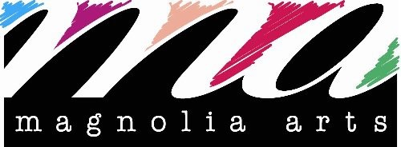
Magnolia Arts Center is a non-profit 501 c 3 organization and welcomes everyone to participate in all our activities

116 S. Washington Magnolia Ar. 71753 870.901.3600
www.magnoliaarts.net . magnoliaarts@magnoliaarts.net
like us on facebook @magnoliaartsar & instgram @magnoliaarts

